Question 1
Write a C program to implement the Producer -Consumer problem using an anonymous pipe.
Question 2
Write a C program to implement the equivalent of the Linux command:
Ls-l | grep”.c”
Using fork(), pipe(), dup2(), and execlp()
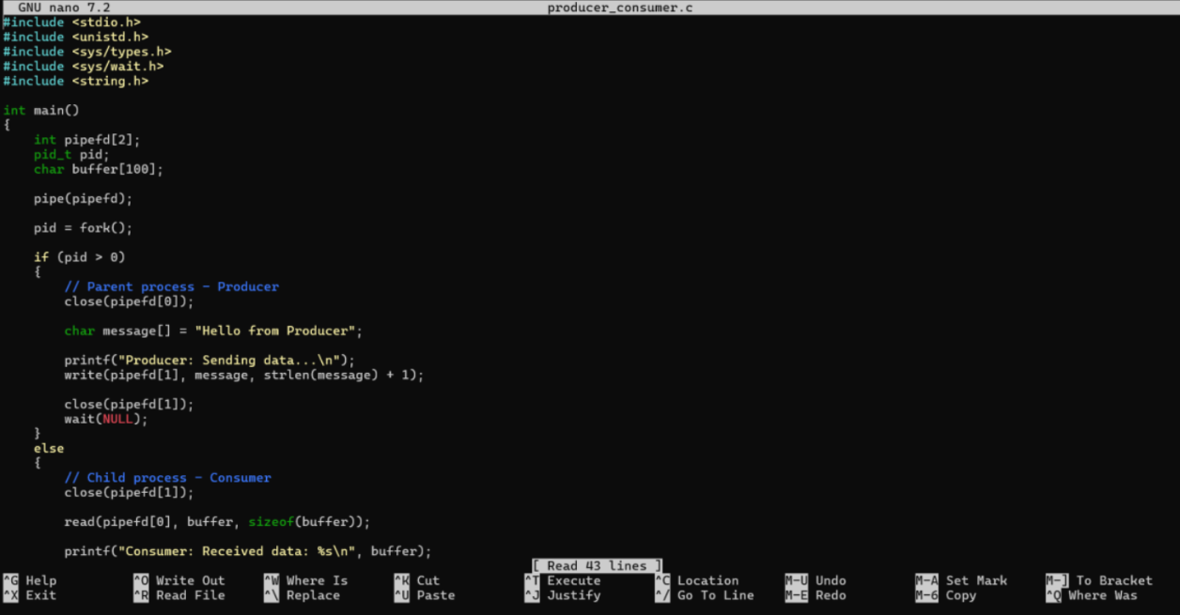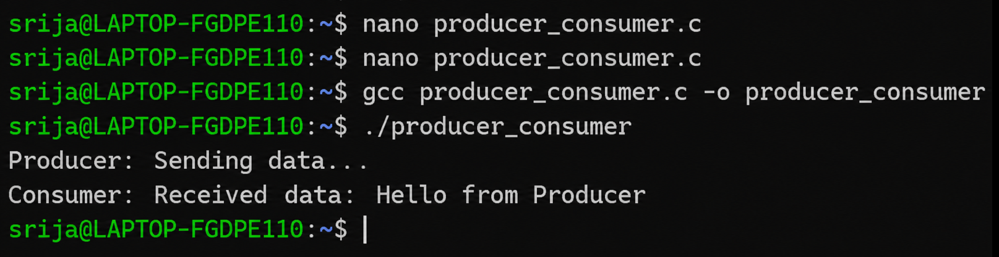
Using system calls
